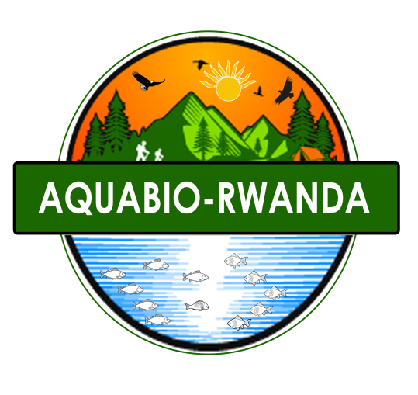

**RWANDA-ESTERN PROVINCE**

**KAYONZA DISTRICT**

**Tel: +250788335646**

**Email:** [**ndericus@gmail.com**](mailto:ndericus@gmail.com)

**NDAGIJIMANA Eric**

**ORGANIZATION PROFILE**

**BACKGROUND**

**AQUABIO RWANDA (Aquatic resources and biodiversity conservation enterprise), it is a youth** initiative to integrate wildlife and aquatic resources management, climate change mitigation and adaptation, environmental management and community sustainable development. Through smart agriculture practices, forestry extension, community based conservation projects, proper water resources use, environmental communication, biodiversity conservation education and ecotourism development. AQUABIO was founded in 2016 by Eric NDAGIJIMANA as an aquatic life conservation social enterprise The Organization was legally registered in 2019. It was founded around Akagera National Park for the purpose of supporting and empowering local communities for safe use of existing resources, biodiversity conservation and sustainable development. Through developed agriculture practices, community based conservation projects, environmental communication and proper use of existing water bodies. Our primary objective is to provide services to forestry, environment protection and biodiversity conservation. We will also focus on land use and water supply, smart agriculture and climate change mitigation and adaptation strategies. We will provide consultancy and support in fisheries and aquaculture development in Eastern Province. AQUABIO enterprise headquarters is in Kayonza-Eastern Province of Rwanda with the initiative of integrating wildlife and aquatic species conservation, safe water and land use and management, smart agriculture and climate change mitigation. It was created to promote sustainable development within safe environment, and improved agriculture services.

**Brief history of the Organization**

August of 2016: Established as a company in the name of aquatic life Conservation enterprise, November 2019: Incorporation of the company under the name of AQUABIO by Eric NDAGIJIMANA after his graduation in Wildlife and Aquatic Resources Management. This initiative has started with the aim of managing water resources, aquatic species management and biodiversity conservation. The idea has come after meeting with community challenges of water scarcity due to poor use and distribution of water. Most of water sources in Rwanda especially wetlands, lakes and rivers are poorly managed and protected. Some of those water sources are hosting aquatic species that are also affected by poor management. These challenges are from poor land use and human pressure on those resources causing erosion, land sliding and run off from hills to the water bodies affecting water quality and existing aquatic species. This also affects human health as they drink dirty water causing water bone diseases. Not on this affecting human health but also poor water distribution where people are losing opportunities of fetching clean water around their home and they collect water from wetlands and water bodies. Most of the wetlands are hosting different aquatic species and also receive more biodiversities coming from protected and non-protected areas coming to enjoy water and drink. From the above reasons, the idea of creating a company which will involve to solve those problems. By implementing water bodies management activities to conserve existing biodiversities, and other wildlife from natural reserves, supporting water distribution activities to supply clean water to the communities. It is from this reason we started working with Bioccop Rwanda which is a biodiversity conservation company and we implemented wetland restoration and management project and Health and sanitation project. The company kept working with partners for capacity building for conservation and community development. As said above from 2016, AQUABIO was working in conservation sector, research activities, capacity building and community development. In 2018, the idea of involving in Agriculture activities came by the initiative of supporting the government program of implementing smart agriculture program and proper land use and from this time the founder was sent in Israel within a period of 12 months for Agro-studies this was due to his passion of giving back to the community through agriculture projects and support services. In 2019, after seeing the improper use of land and water during agriculture practices and community livelihood AQUABIO started to involve in water and land use management. Currently it is involving in water distribution services and management, water body’s management, land use planning and management, agriculture, fisheries and aquaculture development, biodiversity conservation and climate change mitigation and adaptation.

**Our values**

The enterprise upholds the following values as a guideline to its operation and business transactions:

**·** Commitment

· Quick and better services

**·** Teamwork

**·** Professionalism

**·** Flexibility / Adaptability

**·** Social Responsibility

**Our Vision**

Engage in sustainable use of existing resources to develop our country through empowering youth in agriculture, ecotourism, and biodiversity conservation

**Our Mission**

Integrate aquaculture, biodiversity conservation and ecotourism to improve community livelihoods in Eastern Rwanda.

**Our motto**

“Eco-Excellence Is Our Priority”.

**Main goal**

Find solutions to eradicate extreme poverty in Eastern Rwanda by providing quality goods and services in the field of Aquaculture, Ecotourism, and Biodiversity Conservation

**Objective of AQUABIO-Rwanda**

1. Enhance disease free livelihood of communities through clean water supply and food security enhancement.
2. Promote community development through smart agriculture practices and crops variety improvement.
3. Empower people for the use of water resources and organic fertilizers to increase land productivity.
4. Support youth for self-help projects creation for poverty alleviation and business development
5. Enhance communities to involve in climate change mitigation and environmental management through building their capacity on approaches to against climate change impacts and environmental protection.
6. Provide support services on forestry extension, biodiversity conservation and climate change mitigation.
7. Encourage hygiene and sanitation in rural areas of Rwanda through water supply services and water use management.
8. Promote research on biological sciences and community development projects.

This will improve community livelihood, developed youth and well prepared for better future hence this will reduce illegal uses of natural resources and develop self-reliance rather than relying on existing resources from Akagera National Park.

**Why:** because we are in event of the change, century of high speed and developing world, everyone is invited in developing the world but before developing him or her-self and for the time everyone will be in mood of self-reliance the world will be safe for global challenges. It’s from that we shall have to empower people on self-reliance for the sake of environment and biodiversity awareness

**Approaches:** from this idea of empowering local community, we shall provide:

-Training on creating Income Generating Projects

-Training on different sectors of development like idea seeking, design thinking, seeking for new opportunity and project development.

-Training and service delivery on small scale project development and management.

-Training and community outreaches on biodiversity conservation, climate change resilience mitigation measures, environmental management and protection and community intervention.

-Training and service delivery on health and sanitation, food security and agriculture related issues.

### Aims

1. Promote community based conservation and sustainable community development
2. Addressing on climate change mitigation measures by planting trees and developing proper waste management.
3. Develop and Enhance smart agriculture for better future production by involving community into organic farming and agro-forestry development for better evergreen agriculture and green infrastructure in Rwanda
4. Community involvement for hygiene and sanitation as well as food security and malnutrition in rural areas.
5. Develop concept of wildlife and Aquatic conservation in and around protected areas and Involve in research projects and development.
6. To empower youth and women for self-reliance to address challenges of unemployment by green job creation and self-help project through entrepreneurship leader ship development.
7. Uplift community livelihood and socio-economic development through smart agriculture projects development and proper management of existing resources.

**Principle**

-To work hard with innovation, creativity and punctuality in everything for better exploitation of hidden opportunities and safe use of existing resources in a sustainable way.

**Summary of main business activities**

· Research and conservation projects implementation.

· Agriculture practices and service delivery

· Water use and supply activities

· Fisheries and aquaculture practices and consultancy.

· Capacity building and training services

· Environmental Management services.

**About the Company achievement way forward**

AQUABIO is working in partnership with conservation organizations to achieve goals including BIOCOOP, COBACCO, KEC, and RDB. Now it is managing Rugende Fish Farming in Gasabo District. AQUABIO enterprise is working in partnership with COBACCO-Ndego in 2 main activities, tree planting for environmental management and capacity building in biodiversity conservation. AQUABIO is also working hand in hand with BIOCOOP-Rwanda to implement different projects related to biodiversity conservation and community development. We are striving to do many projects ensuring community development and company development, we are planning to do a project of water supply within local communities, involve in fish farming and consultancy services. We have a plan also to run a long-term project connecting local communities’ development and biodiversity conservation around Akagera National Park, this project will cover all categories of generation children, youth and mature people for better understanding of the concept. AQUABIO also is organizing a plan for smart agriculture project which will have irrigation techniques, organic composting, and Agro-forestry practices.

**Partnership**

For better achieving our goals we are partnering with different institutions including BIOCOOP, COBACCA, KEC, MINAGRI, RAB, RDB, RARICO, HOLECO, Kigembe Fish Farming, Rwasava Fish Farming, Rugende Fish Farming and University of Rwanda

**Experience and expertise**.

Our experience in biodiversity conservation, agriculture sector development, and water and forestry resources management has enabled us to involve in those sectors targeting on creation of sustainable poverty alleviation and community development.

**General information**

**Primary contacts for information** or services

Name: Mr. Eric Ndagijimana

Tel: +250788335646

Email 1:ndericus@gmail.com

Email 2:nericus26@gmail.com

KAYONZA-District